Next-Generation Firewall (NGFW)

🛡️ What is a Next-Generation Firewall (NGFW)?
# Source: AI Source: Provided by: [Data Path: Persons Table -> ID Column: 1, Name_En Column: Motasem Essam] -> From: [ChatGPT] on [12/18/2025]
A Next-Generation Firewall (NGFW) is an advanced network security device that goes beyond traditional firewalls by combining deep packet inspection (DPI) with application awareness, intrusion prevention, and other layer 7 (application layer) capabilities.
✅ NGFWs not only block ports and IPs, but also analyze, identify, and control applications and users — even within encrypted traffic.

🧠 What Makes It "Next-Gen"?
# Source: AI Source: Provided by: [Data Path: Persons Table -> ID Column: 1, Name_En Column: Motasem Essam] -> From: [ChatGPT] on [12/18/2025]
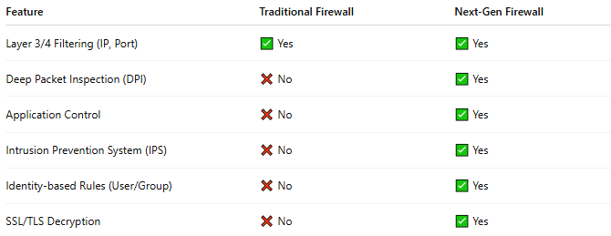

Feature | Traditional Firewall | Next-Gen Firewall
Layer 3/4 Filtering (IP, Port) | ✅ Yes | ✅ Yes
Deep Packet Inspection (DPI) | ❌ No | ✅ Yes
Application Control | ❌ No | ✅ Yes
Intrusion Prevention System (IPS) | ❌ No | ✅ Yes
Identity-based Rules (User/Group) | ❌ No | ✅ Yes
SSL/TLS Decryption | ❌ No | ✅ Yes

🔧 Core Features of NGFW
# Source: AI Source: Provided by: [Data Path: Persons Table -> ID Column: 1, Name_En Column: Motasem Essam] -> From: [ChatGPT] on [12/18/2025]
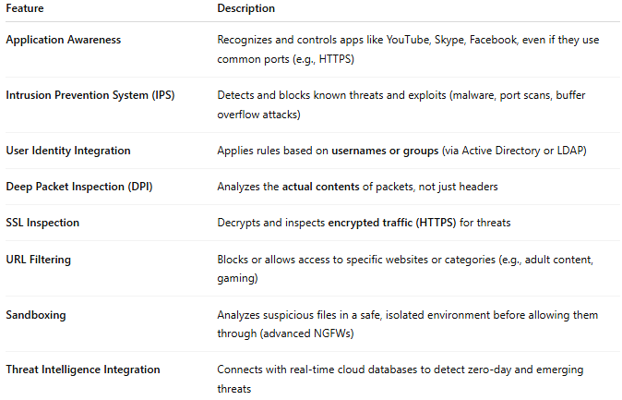

Feature | Description
Application Awareness | Recognizes and controls apps like YouTube, Skype, Facebook, even if they use common ports (e.g., HTTPS)
Intrusion Prevention System (IPS) | Detects and blocks known threats and exploits (malware, port scans, buffer overflow attacks)
User Identity Integration | Applies rules based on usernames or groups (via Active Directory or LDAP)
Deep Packet Inspection (DPI) | Analyzes the actual contents of packets, not just headers
SSL Inspection | Decrypts and inspects encrypted traffic (HTTPS) for threats
URL Filtering | Blocks or allows access to specific websites or categories (e.g., adult content, gaming)
Sandboxing | Analyzes suspicious files in a safe, isolated environment before allowing them through (advanced NGFWs)
Threat Intelligence Integration | Connects with real-time cloud databases to detect zero-day and emerging threats

🧱 NGFW in a Network
# Source: AI Source: Provided by: [Data Path: Persons Table -> ID Column: 1, Name_En Column: Motasem Essam] -> From: [ChatGPT] on [12/18/2025]
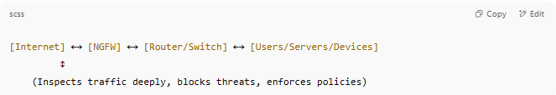
[Internet] ←→ [NGFW] ←→ [Router/Switch] ←→ [Users/Servers/Devices]
↕
(Inspects traffic deeply, blocks threats, enforces policies)

✅ Pros of NGFW
# Source: AI Source: Provided by: [Data Path: Persons Table -> ID Column: 1, Name_En Column: Motasem Essam] -> From: [ChatGPT] on [12/18/2025]
- ✅ High-level visibility and control over apps and users
- ✅ Stops advanced threats missed by basic firewalls
- ✅ Reduces the need for multiple separate security tools
- ✅ Supports compliance (HIPAA, PCI-DSS, etc.)
- ✅ Works well in hybrid cloud/on-prem environments

❌ Cons
# Source: AI Source: Provided by: [Data Path: Persons Table -> ID Column: 1, Name_En Column: Motasem Essam] -> From: [ChatGPT] on [12/18/2025]
- ❌ More complex to configure
- ❌ Higher cost than traditional firewalls
- ❌ May require more hardware resources for DPI/SSL inspection
- ❌ Risk of latency if not properly sized for traffic volume

🏷️ Popular NGFW Vendors
# Source: AI Source: Provided by: [Data Path: Persons Table -> ID Column: 1, Name_En Column: Motasem Essam] -> From: [ChatGPT] on [12/18/2025]
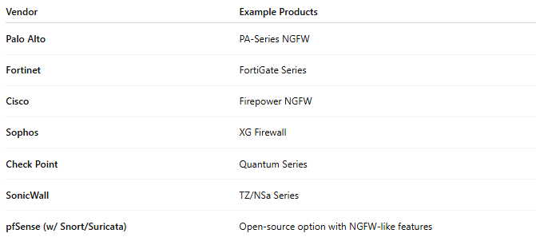

Vendor | Example Products
Palo Alto | PA-Series NGFW
Fortinet | FortiGate Series
Cisco | Firepower NGFW
Sophos | XG Firewall
Check Point | Quantum Series
SonicWall | TZ/NSa Series
pfSense (w/ Snort/Suricata) | Open-source option with NGFW-like features

📌 Summary
# Source: AI Source: Provided by: [Data Path: Persons Table -> ID Column: 1, Name_En Column: Motasem Essam] -> From: [ChatGPT] on [12/18/2025]
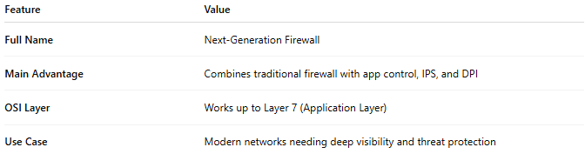

Feature | Value
Full Name | Next-Generation Firewall
Main Advantage | Combines traditional firewall with app control, IPS, and DPI
OSI Layer | Works up to Layer 7 (Application Layer)
Use Case | Modern networks needing deep visibility and threat protection

